F162X alarm code function instructions
Fangling CNC 2020-09-01 16:30

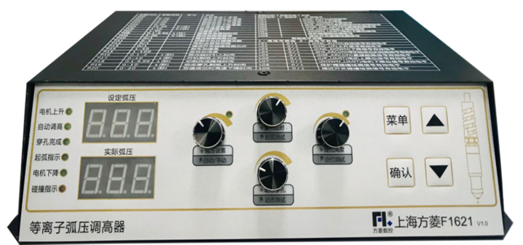
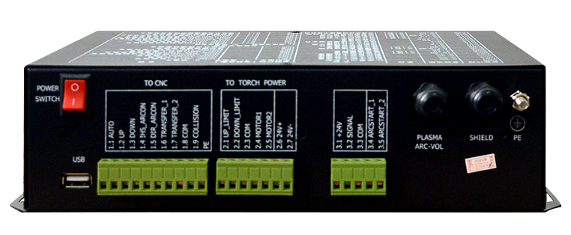

common fault alarm signals during use, such as collision signal, motor limit alarm signal, etc. The program itself will record these faults and display them on the screen or digital tube in the form of alarm codes . After-sales engineers or customers themselves can quickly judge the fault status of the height controller through these alarm codes, or query the fault alarms that have occurred recently, without repeated testing and improve the efficiency of problem solving .

Feature Highlights
1. The latest 10 alarm codes can be saved without power failure.
2. There is no need to manually clear the alarm code, after the fault is eliminated, the alarm code will be automatically eliminated.
3. When multiple alarms occur at the same time, the alarm code can be displayed cyclically.
4. A new historical alarm record interface is added to the panel, which is convenient for users to inquire.
5. The history record can be cleared through the newly added P34 parameter.

use say
1. After starting up, press the "Menu" button 4 times continuously to enter the alarm code history interface, as shown in the figure below.
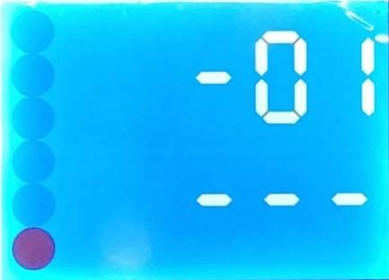
You can use the "+" and "-" buttons to switch the serial number 01-10 to view the last 10 alarm codes saved.
2. When there is an error in the height controller, Err will be displayed on the upper part of the main interface, and the alarm code will be displayed on the lower part. After troubleshooting, the alarm code will disappear automatically. Please refer to the figure below for the alarm example.
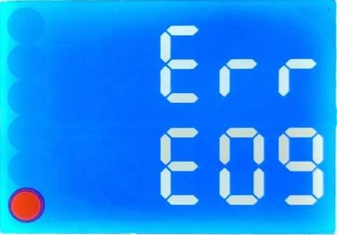
3. If you want to clear the last 10 alarm codes saved, you can switch to the P34 parameter through the menu button, and change its value from 0 to 1.
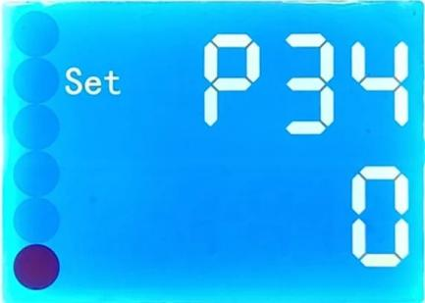
Corresponding alarm codes and solutions
alarm code | Remark | Solution
E00 | no alarm | none
E01 | Bus disconnection alarm | Check the bus connection between the system and the height controller, make sure the connection is correct, and the alarm will disappear
E02 | Parameter save error | It will only appear in F1631, and this alarm will appear when the system parameters are saved incorrectly. The system will automatically repair
E03 | Parameter loading error | It will only appear in F1621 and F1631, the system parameters have added new parameter verification, and this alarm will appear if the verification is incorrect. After F1621 has this alarm, press "Confirm" twice, and it can be repaired after restarting.  Ignore F1631, it will be automatically repaired.  After this alarm is repaired, the parameters may be restored to the factory parameters, please back up the parameters by yourself at any time.
E04 | Return to zero timeout | reserved.
E05 | Location detection timed out | reserved.
E06 | Arc detection timeout | reserved.
E07 | Arc break alarm | Please consult the after-sales engineer about the solution to the "broken arc alarm", and the alarm will disappear after solving it.
E08 | Protective cap collision alarm | This signal means that the collision detection circuit of the protective cap has sent a collision signal. Check whether the protective cap is operating normally. For details, please consult our after-sales engineer.
E09 | Proximity switch collision alarm | This signal means that the collision detection circuit of the protective cap has sent a collision signal. Check whether the proximity switch is operating normally. For details, please consult our after-sales engineer.
E10 | Upper limit alarm | The cutting torch touches the upper limit or the parameter settingof the effective level of the upper limit is wrong. After the upper limit switch returns to normal, the alarm will disappear.
E11 | Lower limit alarm | The cutting torch touches the upper limit or the effective level parameter setting of the upper limit is wrong. After the lower limit switch returns to normal, the alarm will disappear.
E12 | Disconnection alarm | It will only appear in the capacitive height adjustment mode, check whether the connection between the capacitive sensor connection line of the capacitive height controller and the system is loose.
E13 | Out of board alarm | It will only appear in the capacitance height adjustment mode. Generally, this alarm will appear when the cutting torch is moved outside the board, and the alarm will disappear when the cutting torch is moved back to the board.
E14 | Protective cap adhesion alarm | This alarm will appear if the protective cap collision signal continues to send out for more than 3 seconds. If this alarm occurs, please check whether the protective cap is faulty and why it keeps sending out the collision signal.
E15 | Proximity switch adhesion alarm | This alarm will occur if the proximity switch collision signal is sent continuously for more than 3 seconds. If this alarm occurs, please check whether the proximity switch is faulty and why it keeps sending the collision signal.

